# Checking and Validating the Partition Table

## Standard Programming

Download tool will validate the existing partition table in the EVB, for the following condition:

|  |  |  |
| --- | --- | --- |
| **Partition Name** | **Sector Start** | **Sector Count** |
| BOOT | 1 | 63 |
| VIRT | 64 | >=65 |
| SYSFS | 496 | 16 |

Table 1: Standard programming: Partition Table – Condition

**Case 1: Existing partition matches SSBL programming partition**

If the existing partition does not satisfy the condition mentioned in Table 1, but matches with the SSBL programming partition, the user is notified by a pop-up message. The user will then have the option (Yes/No) to either flash the default partition table or terminate the action (i.e., correct the deviation manually and try again).

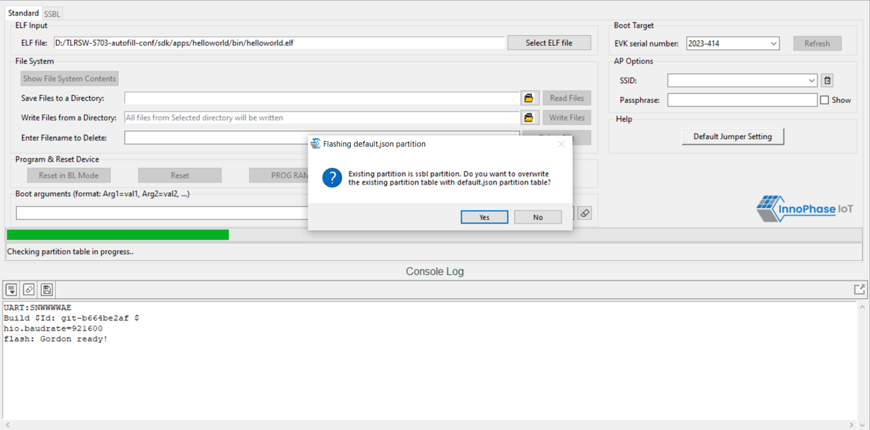

Figure 34: Deviation from the standard programming partition – matches SSBL programming partition

If the user selects ‘No’ and chooses not to back-up to the local system, action is terminated requiring the user to manually correct the deviation to proceed further as shown in Figure 35.

Figure 35: Standard programming - action terminated

**Case 2: Existing partition neither satisfies Standard programming partition, nor SSBL programming partition**

If the existing partition neither satisfies the condition mentioned in Table 1, nor the SSBL programming partition, the user is notified by a pop-up message. The user will then have the option (Yes/No) to either flash the default partition table or terminate the action (i.e., correct the deviation manually and try again).

Figure 36: Deviation from the standard programming partition - no match

**Note**: In case the user-defined partition table meets the condition mentioned in Table 1, but with VIRT partition less than the application VM image size, a pop-up message notifies the same to the user with an option of overwriting existing partition with default partition table, as shown in Figure 37.

Figure 37: VM image does not fit in partition

1. If the user chooses to flash the default partition (option: Yes):

Download tool will back-up the contents of SYSFS and DATA partition of existing partition table. Once the default partition is flashed successfully, the backed-up contents of SYSFS and DATA partitions are re-flashed to the corresponding new location as per the default partition table.

* 1. In case the backed-up contents of SYSFS does not fit into the corresponding new location as per the default partition table (regarding size), user will have an option (Yes/No) to either back-up the content to local system and clear the data in EVB or correct the deviation manually and try again.

Figure 38: Backed-up contents of SYSFS

* + 1. If the user chooses to back-up to local system (option: Yes):

The contents will be saved in the local system and the user will be notified with the folder path through a popup message.

Figure 39: Contents saved in the local system

* + 1. If the user does not choose to back-up to local system (option: No):

The action will be terminated, and user will be required to correct the deviation manually to proceed further.

Figure 40: Action terminated requiring to correct the deviation manually

* 1. In case the back-up contents of DATA partition do not fit the corresponding location in the default partition, the contents will be saved in the local system and the user will be notified with the folder path through a pop-up message. Also, the user will be intimated to write the new certification file to DATA partition using Write Files option.

Figure 41: Back-up contents of DATA partition

* 1. However, if the user does not choose to flash the default partition (option: No):

The action will be terminated, and the user will be required to correct the deviation manually to proceed further.

Figure 42: User does not choose to flash default partition – action terminated

## SSBL Programming

Download tool will validate the existing partition table in the EVB, for the following condition:

|  |  |  |
| --- | --- | --- |
| **Partition Name** | **Sector Start** | **Sector Count** |
| BOOT | 1 | 31 |
| BOOT | 32 | 352 |
| DATA | 384 | 112 |
| SYSFS | 496 | 16 |

Table 2: SSBL programming: Partition Table – Condition

If the existing partition does not satisfy the condition mentioned in Table 2, but matches with the default programming partition, the user is notified by a pop-up message.

The user will then have the option (Yes/No) to either flash the default partition table or terminate the action (i.e., correct the deviation manually and try again).

Figure 43: Deviation from the SSBL programming partition – matches default programming partition

If the user selects ‘No’ and chooses not to flash the default SSBL partition table, action is terminated requiring the user to manually correct the deviation to proceed further as shown in Figure 44.

Figure 44: SSBL programming - action terminated